# Portfolio website of A. Prinsloo – Code screenshots

Contents

Portfolio website of A. Prinsloo 1

Screenshots of the code 2

Home page 2

Projects page 4

Skills page 5

Education / Work experience page 8

Contact page 9

CSS external file 11

JavaScript external file 27

References 28

# Screenshots of the code

## Home page

## Projects page

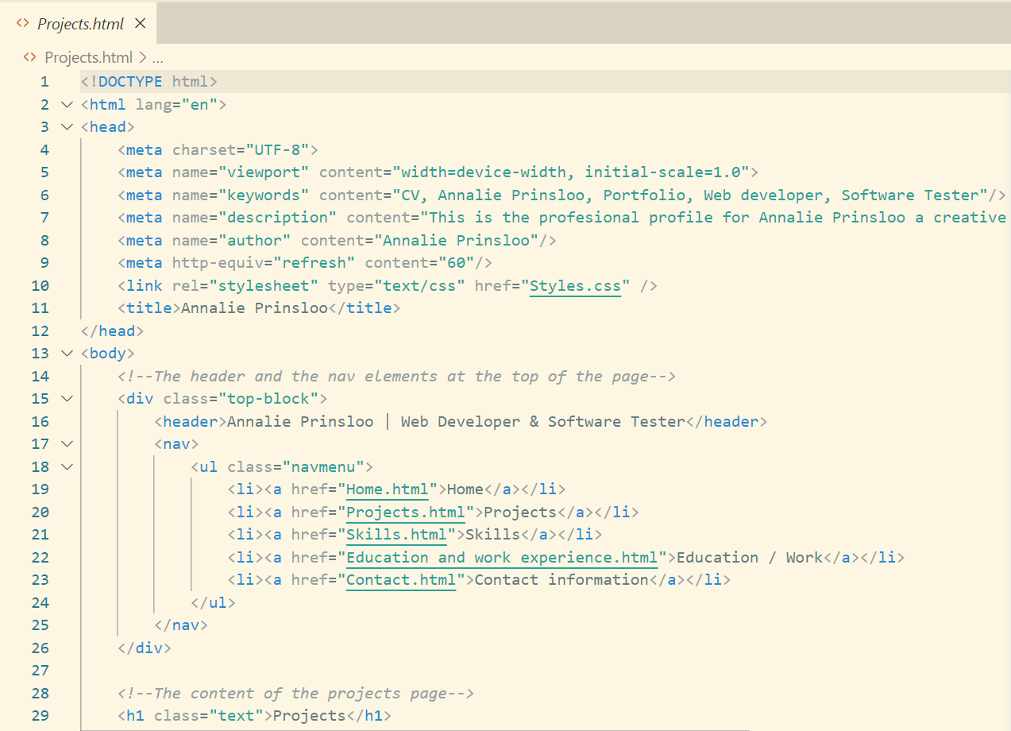

## Skills page

## Education / Work experience page

## Contact page

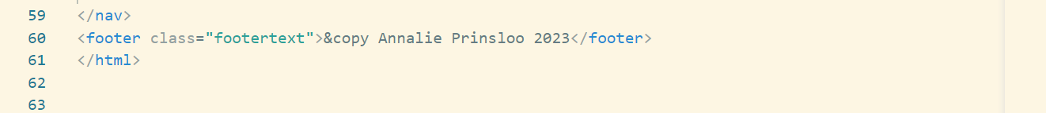

## CSS external file

## JavaScript external file

# References

1. EmailJS, 2023. Send Email Directly from Your Code. Available at: <https://www.emailjs.com/> (Accessed: 2023/11/18).
2. DarkCode. 2018. Simple Text Animation Just By Using HTML & CSS. Available at: <https://www.youtube.com/watch?v=Syg_9iB1vco&list=PLxA4Fu_DdmxZLdmOuKTur3yN7Y5-o2Nyy&index=20> (Accessed: 2023/11/18).
3. How To Host A Website On Xampp Server, no date. Entrepreneur Makeover. Available at: <https://www.entrepreneurmakeover.com/how-to-host-a-website-on-xamp-server> (Accessed: 2023/11/19).
4. Lari, A. no date. How to Access Your Localhost from Mobile: Windows and macOS. Medium. Available at: <https://medium.com/@amaanlari5/how-to-access-your-localhost-from-mobile-windows-and-macos-7cb7bdb4aa4f> (Accessed: 2023/11/19).
5. QuickCodingTuts. 2023. Build A Working Contact Form with Email JS | Quick Tutorial. Available at: <https://www.youtube.com/watch?v=qxWDVRyc95E&list=PLxA4Fu_DdmxZLdmOuKTur3yN7Y5-o2Nyy&index=19> (Accessed: 2023/11/18).